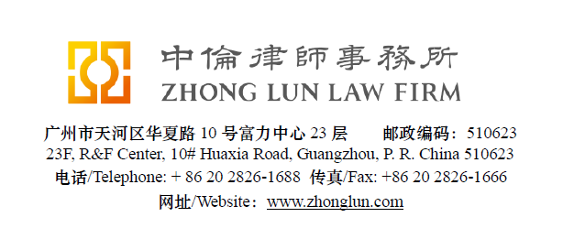

Invoice / 收款通知书

Date  日期 | 28/07/2019 | ZL Invoice Reference  中伦收款通知编号 |  | 064802-0001/017
Client  客户 |  | OYO Hospitality & Information Technology (Shenzhen) Co., Ltd.  遨游酒店信息技术（深圳）有限责任公司  4/F, Hua Fu Yang Buidling  No 1, Ke Wen Road  Nanshan District, Shenzhen
Subject Matter  事项 | Retainer | Service Period  服务期限 | June 2019
Legal Fee  律师费 | RMB 18,049.7 | Reimbursement  报销费用 | RMB 4,519.6
Sum Now Due  总应付款 | RMB 22,569.3

Please make the payment to the banks account as follows:
请将上述款项付至下列账户：

Account Number  账号 | 1209 0403 9310 502 | Swift Code  银行代码 | CMBCCNBS131
Account Name  账户名称 | Beijing Zhong Lun Law Firm Guangzhou Office  北京市中伦（广州）律师事务所
Bank Name  开户行 | China Merchants Bank, Guangzhou Branch, R&F Center Subbranch  招商银行广州分行富力中心支行
Address  地址 | 2/28F R&F Center, 10 Huaxia Road, Guangzhou, China  广州市华夏路10号富力中心2/28楼

Zhong Lun Law Firm 中伦律师事务所
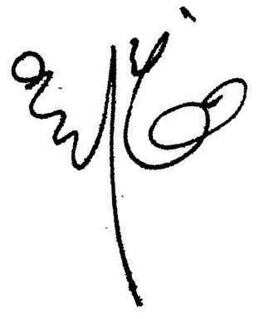


Charge Details / 收费明细

To our Professional Charges for our service rendered in respect of the following:
中伦律师事务所就如下事宜提供了专业服务：

Date 日期 | Description of Services  服务记录 | Personnel  人员 | Hours Spent 所用小时数
03/06/19 | Searching for the domain name list and sending the same to Kent WOO and Michael WONG. | Helen W | 0.3
 | Reviewing and updating the response to the China JV-DD Checklist prepared by Helen WONG. | Michael W | 3.9
04/06/19 | Answering the phone call from Richard WANG and forwarding the AIC file and the AoA of Beijing VIE to him. | Helen W | 0.2
05/06/19 | Reviewing the response to the DD Checklist and the related documents prepared by Michael WONG and Helen WONG and discussing the same with Helen WONG. | Kent W | 1.5
 | Discussing with Kent WOO the response to the DD Checklist and revising the same as discussed. | Helen W | 1.1
11/06/19 | Preparing and revising the note to Richard WANG to check the status of the shareholding termination arrangement. | Helen W | 0.4
17/06/19 | Reviewing the exclusive service agreement and discussing the same with Helen WONG. | Kent W | 0.5
 | Discussing with Kent WOO on the exclusive service agreement among OYO Shenzhen, OYO Shanghai and Beijing VIE and discussing the same with Richard WANG on the waiver to be issued by OYO Shanghai. | Helen W | 0.4
21/06/19 | Sending the transfer agreement and etc. of Beijing VIE to Richard WANG as required. | Helen W | 0.3
25/06/19 | Preparing the waiver to be issued by OYO Shanghai to Lillian XU and sending the same to Richard WANG. | Helen W | 1.2
28/06/19 | Reviewing the waiver of OYO Shanghai commented by Richard WANG, commenting on the same and sending the further commented version to Richard WANG. | Helen W | 0.3

For clarification we have set out below a table showing the hours spent by ZL personnel:
为明确起见，我们在下表中列明了中伦律师事务所工作人员所花费的时间：

Personnel  人员 | Hours Spent  总计小时数 | Rate (USD)/hour  每小时费率 | Legal Fee (USD)  律师费
Kent WOO/Helen WONG/Michael WONG | 10.1 | 259 | 2,615.9
 |  | Total/合计: | 2,615.9
 |  | In RMB: | 18,049.7

For clarification we have set out below a table showing the details of reimbursement:
为明确起见，我们在下表中列明了报销费用明细：

Time  日期 | OOP Description  内容描述 | Expense in RMB  费用 (人民币)
2019-06 | Courier fee. | 65
 | Travelling and accommodation fee for the travel to Beijing to acquire files from the BIC and make the invoice stamp. | 4,454.6
 | Total: | 4,519.6

Please kindly indicate the ZL Invoice Reference number on your bank processing document and provide us a copy of the bank confirmation for the payment. /请在银行付款单据上标明中伦收款通知编号，并向我方提供相关银行确认书。
Please pay equivalent foreign currency if an RMB account is not available. /若未能支付人民币，请支付等值外币。
Please indicate the FULL name in the bank advice and state the FULL name at the remark or note section on the bank advice./ 请在银行付款单据上列明全称并在汇款附言或备注栏填入收款人全称。

